

**Computer & Electronic Engineering**

**Final Year Project "Music Host Interface"**

**Sprint 6: Week 1 Log**

**Thomas Flynn**

**Project Supervisor: Brian O'Shea**

**21/02/16 - 27/02/16**

**Entry 1: 24/02/16**

Today I renewed my subscription for Azure.

I integrated the Azure SQL database into the JavaFX GUI project.

I setup the database to have foreign key for each of the user login songs.

**Entry 2: 28/02/16**

Today I managed to populate and download data from database.

I started work on the download thread.

**Task completed:**

Pay for Azure subscription

Azure database working in GUI

create Azure credentials class

Create and populate Azure database with foreign keys

**GIT Repositories:**

No commits made.

**Board at the start of the week:**

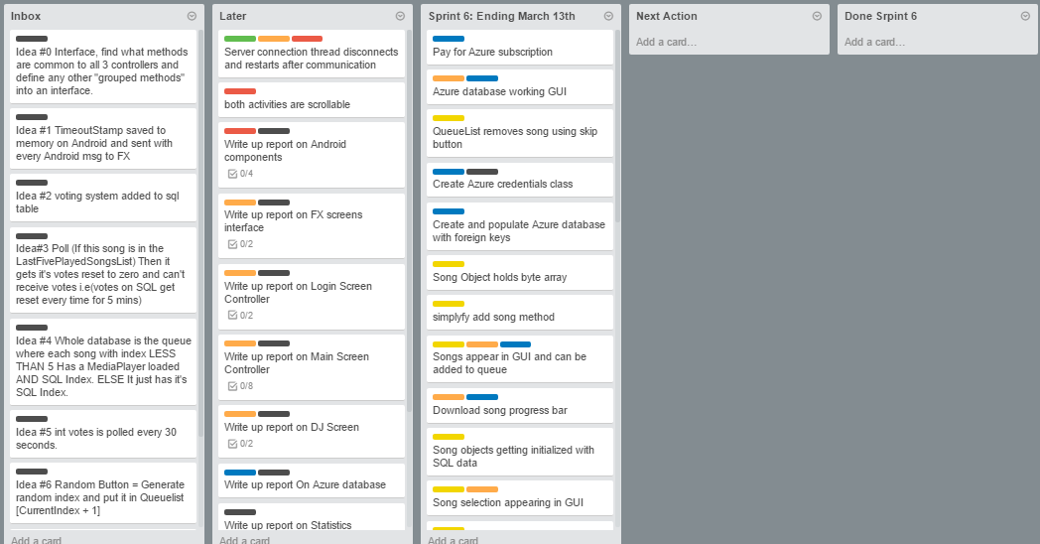

**Board at the end of the week:**

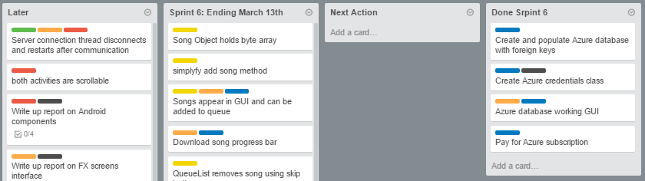

**Weekly time Log bar chart:**

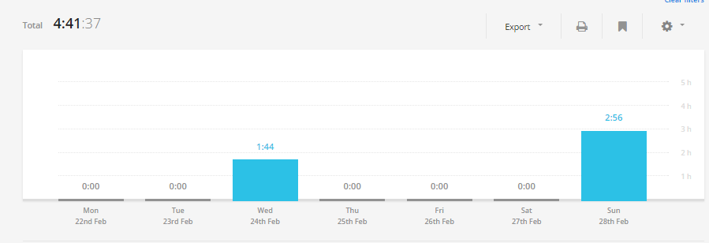

**Weekly Time Log:**

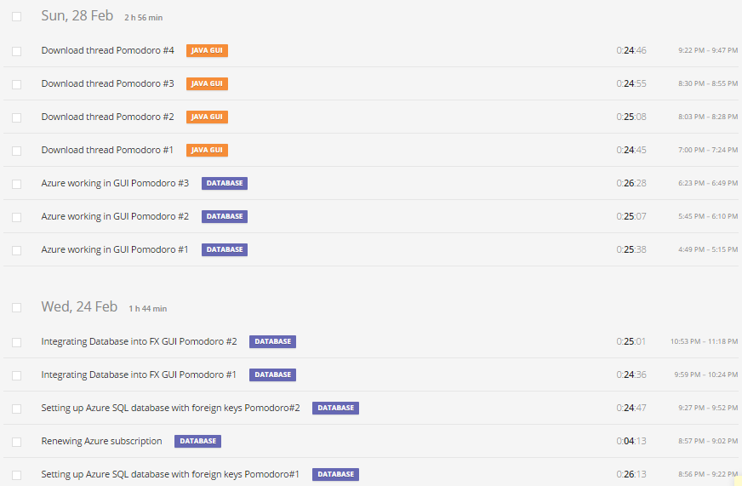

**Weekly log Pie Charts:**

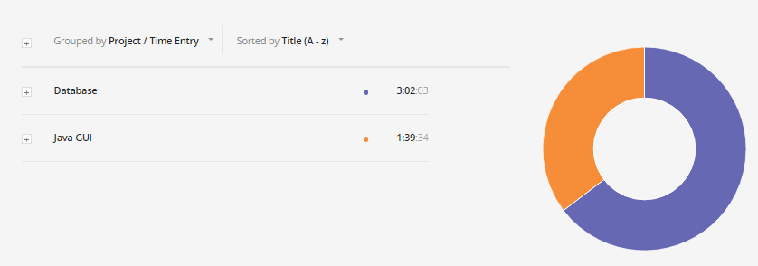

**Screenshots progress:**

**UserLogin table:**

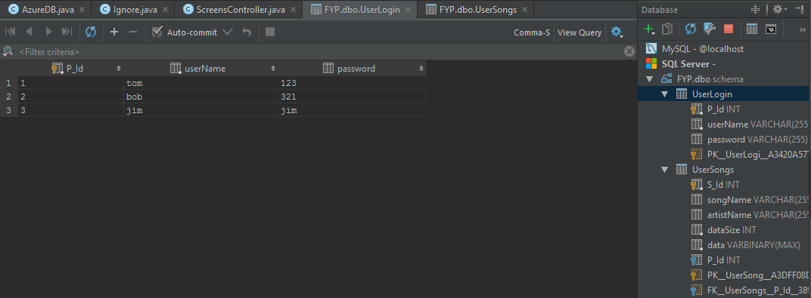

**UserSongs table:**

